**Haseeb_Ullah_F20232661009_Raiz_Ahmed_Lab3**

**Example 3.1:** This example demonstrates declaration and initialization of variables

#include <iostream> using namespace std;

int main ()

{

// declaring variables: int a, b;

int result;

a = 5;

b = 2;

a = a + 1; result = a - b;

Here’s the program’s output:

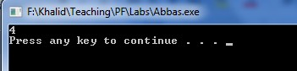

cout << result; return 0;

}

**My Work at Lab**

|  |
| --- |
| #include <iostream>  using namespace std;  int main()  {  int cost, prize;  int profit;  cost = 200;  prize = 500;  cost = cost + 20;  profit = prize - cost;  cout << profit;  return 0;  } |

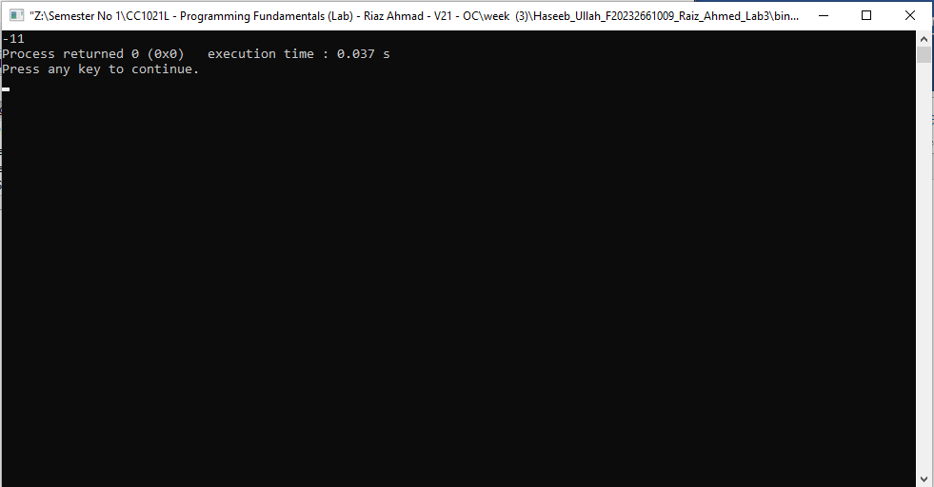

**Example 3.2:** This program illustrates different techniques to initialize a variable.

// initialization of variables #include <iostream>

using namespace std;

int main ()

{

int a = 5; // initial value: 5

int b(3); // initial value: 3

int c = 2; // initial value: 2. Also try int c{2};

int result; // initial value undetermined

a = a + b; result = a - c; cout << result;

return 0;

}

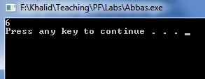Here’s the program’s output:

**My Work at Lab.**

|  |
| --- |
| #include <iostream>  using namespace std;  int main()  {  int x = 5;  int y (6);  int z {22};  int total;    x = x + y;  total = x - z;    cout << total;    return 0;  } |

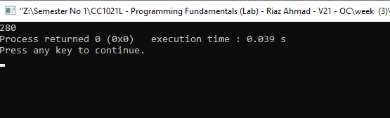

**Example 3.3:** This program illustrates use of strings.

// my first string #include <iostream> #include <string> using namespace std;

int main ()

{

string myname;

Here’s the program’s output:

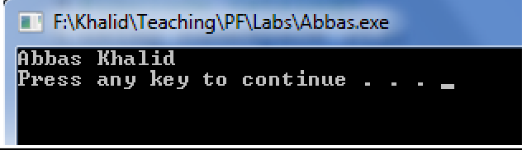myname = " Abbas Khalid"; cout << myname;

return 0;

}

**My Work at Lab.**

|  |
| --- |
| #include <iostream>  #include <string>  using namespace std;  int main()  {  string sirname;  sirname = "Raiz Ahmed";    cout << sirname;  return 0;  } |

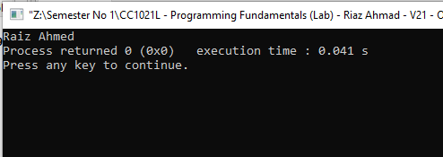

**Example 3.4:** This program calculates the area of the circle. The area of the circle is **π**r². The value of **π** is constant that is 3.14 but radius can change so this program gets the value of radius variable form user and calculate the area on that value.

#include <iostream> using namespace std;

int main ()

{

float radius,area;

cout<<"Enter radius of circle: "; cin>>radius;

area = 3.14*radius*radius;

cout<<"Area of the circle is:"<< area<<endl;

return 0;

}

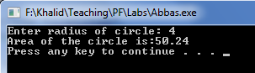Here’s the program’s output:

**My Work at Lab.**

|  |
| --- |
| #include <iostream>  #include <cmath>  using namespace std;  int main()  {  float radius, area;  cout << "Enter Radius of the circle: ";  cin >> radius ;  area = 3.14 * pow(radius, 2);  cout <<"Area of the circle is:"<< area <<endl;  return 0;  } |

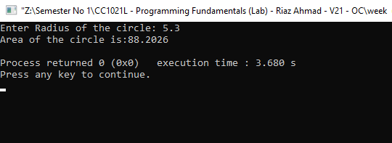

**Example 3.5:** This program illustrates the addition on character values.

#include <iostream> using namespace std;

int main ()

{

char x, y ;

int z ; x = 'a' ;

y = 'b' ;

z = x + y ; //Add the assci value of 'a' with assci value of 'b'. cout<<z<<endl;

return 0;

}

Here’s the program’s output:

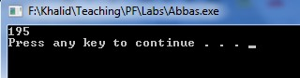

**My Work at Lab.**

|  |
| --- |
| #include <iostream>  using namespace std;  int main()  {  char A, Z;  int t; //total of Char numbers  A = 'g';  Z = 'h';  t = A + Z;  cout << t << "\n";  return 0;  } |

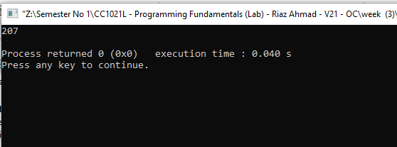

**Example 3.6:** This program illustrates the use of sizeof() function which is used to find the memory space allocated for each C++ data type.

#include <iostream> #include <climits> using namespace std; int main ()

{

int a; char b; float c; double d;

cout<<"Storage size for int data type:"<<sizeof(a)<<endl; cout<<"Storage size for char data type:"<<sizeof(b)<<endl; cout<<"Storage size for float data type:"<<sizeof(c)<<endl; cout<<"Storage size for double data type:"<<sizeof(d)<<endl;

return 0;

}

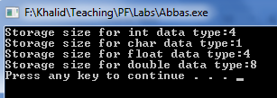Here’s the program’s output:

**My Work at Lab**

|  |
| --- |
| #include <iostream>  using namespace std;  int main()  {  int c;  char A;  float v;  double k;  cout<<"Storage size for int data type:"<<sizeof(c)<<endl;  cout<<"Storage size for char data type:"<<sizeof(A)<<endl;  cout<<"Storage size for float data type:"<<sizeof(v)<<endl;  cout<<"Storage size for double data type:"<<sizeof(k)<<endl;  return 0;  } |

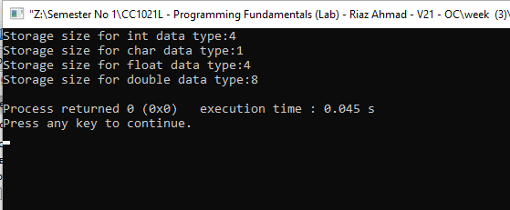

**Example 3.7:** A program to illustrate Octal, Decimal and Hexadecimal representation using ***cout***.

#include <iostream> using namespace std; int main()

{

int n = 54;

cout << std::oct << "oct - " << n << '\n'; cout << std::dec << "dec - " << n << '\n'; cout << std::hex << "hex - " << n << '\n';

return 0;

}

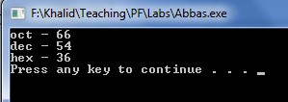Here’s the program’s output:

**My Work at Lab.**

|  |
| --- |
| #include <iostream>  using namespace std;  int main(){    int n = 33;  cout << oct << "oct - " << n << '\n';  cout << dec << "dec - " << n << '\n';  cout << hex << "hex - " << n << '\n';  return 0;  } |

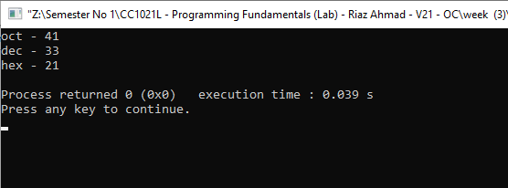

**LAB EXERCISE**

**Exercise 3.1:** Write a program to compute circumference of a circle.

**My Work at Lab**

|  |
| --- |
| #include <iostream>  using namespace std;  int main() {    float pi = 3.14;  double radius;  double circumference;    cout << "Enter the radius of the circle: ";  cin >> radius;    circumference = 2 * pi * radius;  cout << "The Circumference of the circle is: " << circumference ;    return 0;  } |

### 

**Exercise 3.2:** Write a program that takes any ASCII value from user and display next five char after that ASCII value.

Hints: - if user enters 95, your program should display the char against the ASSCII value 96,97,98,99 and 100.

### My Work at Lab

|  |
| --- |
| int main(){int value;cout << "Enter an ASC value: " ;cin >> value;for (int i = 0; i < 4; i++){char num = value + i;cout << num << "" ;}return 0;} |

### 

**HOME WORK**

**1: Write a program converts a temperature from Celsius to Fahrenheit. Use the following formula: F = 1.8 x C + 32.**

|  |
| --- |
| #include <iostream>  using namespace std;  //Write a program converts a temperature from Celsius to Fahrenheit.  //Use the following formula: F = 1.8 x C + 32.  int main() {    double celsius;  double fahrenheit;    cout << "Enter the Celsius: ";  cin >> celsius;    fahrenheit = (1.8 * celsius) + 32;    cout << "Temperature in Fahrenheit is: " << fahrenheit;    return 0;  } |

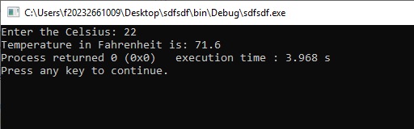

**2.Write a program that reads three integers representing hours,minutes, and seconds of a time.Then it should calculate the equivalent time in seconds**.

|  |
| --- |
| #include <iostream>  using namespace std;  int main() {  int hours;  int minutes;  int seconds;  int totalSeconds;  cout << "Enter hours, minutes, seconds \n";  cin >> hours;  cin >> minutes;  cin >> seconds;  totalSeconds = hours * 3600 + minutes * 60 + seconds;  cout << "Total Second is: " << totalSeconds;  return 0;  } |

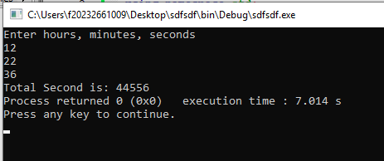

**3.Write a program that input length and width from the user, it calculates and displays area of rectangle by using formula Area=(length)(width).**

|  |
| --- |
| #include <iostream>  using namespace std;  // 3. Write a program that input length and width from the user,  //it calculates and displays area of rectangle by using formula Area=(length)(width).  int main() {  double area, lenght, width;  cout << "Enter the Lenght of the area: ";  cin >> lenght;  cout << "Enter the width of the area: ";  cin >> width;  area = lenght * width;  cout << "Total Area is: " << area;  return 0;  } |

